Machine Learning Report

**Attrition Analysis by Department**: Sales and Human Resources have higher attrition rates compared to Research & Development.

* **Salary Band Distribution**: Most employees fall within the "Low" and "Medium" salary bands.
* **Effect of Promotions**: Employees who have not been promoted for many years tend to leave more frequently.
* **Model Performance**:
* Logistic Regression achieves 87% accuracy but struggles with recall for quitting employees.
* Decision Tree has slightly lower accuracy (81%) and does not generalize well.
* A neural network model is trained with high accuracy (100% on training data), but it may be overfitting.

Tableau Report

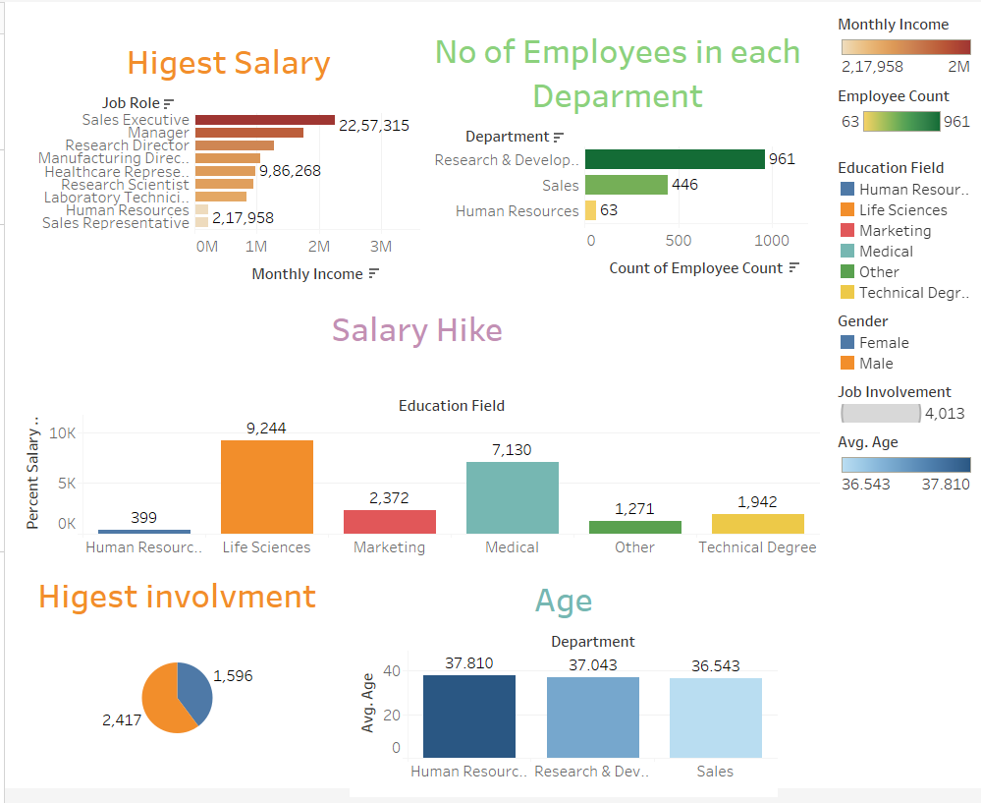

**Employee Attrition & Insights Report**

**Attrition Analysis**

* **Overall Attrition Rate**: 16% of employees have left the company.
* **Department-wise Attrition**:
  + **Human Resources**: 19% attrition.
  + **Sales**: 21% attrition.
  + **Research & Development**: 14% attrition.
* **Factors Affecting Attrition**:
* Employees with **low salary bands** are more likely to leave.
* **Lack of promotions** increases attrition, especially after 7+ years without a promotion.
* **Higher attrition among single employees** compared to married or divorced employees.

**Salary & Compensation**

* **Highest Salary by Job Role**:
  + **Sales Executive**: ₹22,57,315
  + **Manager**: ₹9,86,268
  + Other roles (e.g., Research Scientist, Human Resources) around ₹2,17,958.
* **Salary Hike by Education Field**:
* **Life Sciences & Medical**: Highest salary hikes.
* **Human Resources & Other Fields**: Relatively lower salary hikes.

**Predictive Modeling Results**

* **Logistic Regression**:
  + Accuracy: **87%** but struggles with predicting attrition.
* **Decision Tree**:
  + Accuracy: **81%** but lacks strong generalization.
* **Deep Learning Model**:
* Initially **overfitted with 100% accuracy**, later improved with an adjusted model.